[Analysis of Government Policy Options for the Australian Private Hospital Insurance Market]

[Hasim Rahman, Studio 1, Assessment-3]

[University of Technology Sydney]

**Table of Contents**

Introduction

1.1 Background

1.2 Problem Statement

1.3 Objectives

Investigation of Claim

2.1 Overview of the Private Health Insurance Market

2.2 Examination of Declining Membership

2.3 Relevant Statistics and Research Reports

Analysis of Response 1: Subsidy to Insurers

3.1 Policy Context and Rationale

3.2 Impact on Market Equilibrium

3.3 Potential Effects on Related Markets

3.4 Winners and Losers

3.5 Limitations

Analysis of Response 2: Lowering the Medicare Levy Surcharge Threshold

4.1 Policy Context and Rationale

4.2 Impact on Market Equilibrium

4.3 Incentive Effects on Health Insurance Enrolment

4.4 Winners and Losers

4.5 Limitations

Analysis of Response 3: Regulatory Reforms to Medical Equipment

5.1 Policy Context and Rationale

5.2 Impact on Market Equilibrium

5.3 Potential Effects on Related Markets

5.4 Winners and Losers

5.5 Limitations

Recommendations

6.1 Evaluation Criteria

6.2 Recommended Policy Option(s)

6.3 Justification for the Recommendation

Conclusion

References

1. **Introduction**

This report analyses the current state of the Australian private hospital insurance (PHI) market and explores three potential policy responses proposed by the government to address the market decline. The reason there is a decline in interest for PHIs (Private Hospital Insurance) by younger and healthier individuals. This has raised concerns about a potential market "death spiral." The report critically examines each policy option to assesses their potential effects on market equilibrium and the government policy. The report concludes with a recommendation for the government based on the goal of delivering high-quality healthcare at the lowest possible cost.

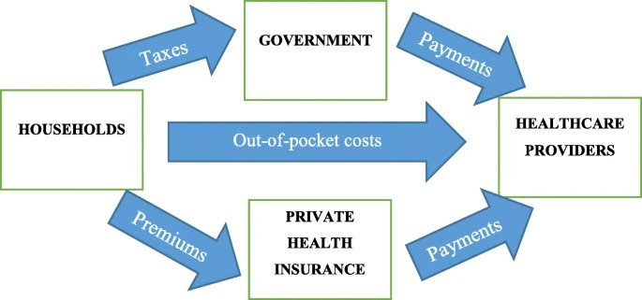

1. **Investigation**

2.1) So, we begin by analysing the claim that “The PHI in Australia is declining.” Upon looking at the data from the Private Health Insurance Annual Coverage Survey from APRA, we can find that in the past 7 years in all categories there has been a percentage decline in the number of PHI buyers, except for the short increase since the pandemic, which created fear mongering among the citizens which made them take their health more seriously.

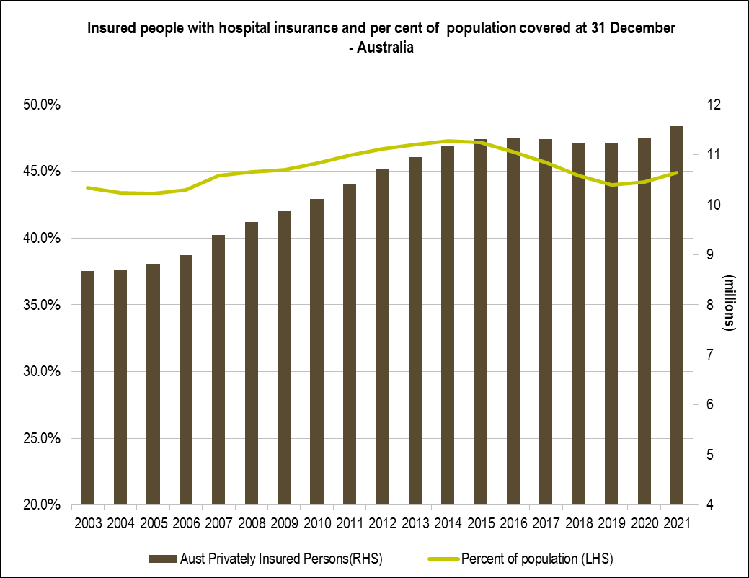

2.2) To take a deeper look, we can find that the younger population (post 18 and less than 35) have opted for Medicare, as most of the people during this age leave their parents' home and lack the capital freedom to procure private healthcare. We can also see the post pandemic boom even in groups where there was a declining rate of growth in previous years.

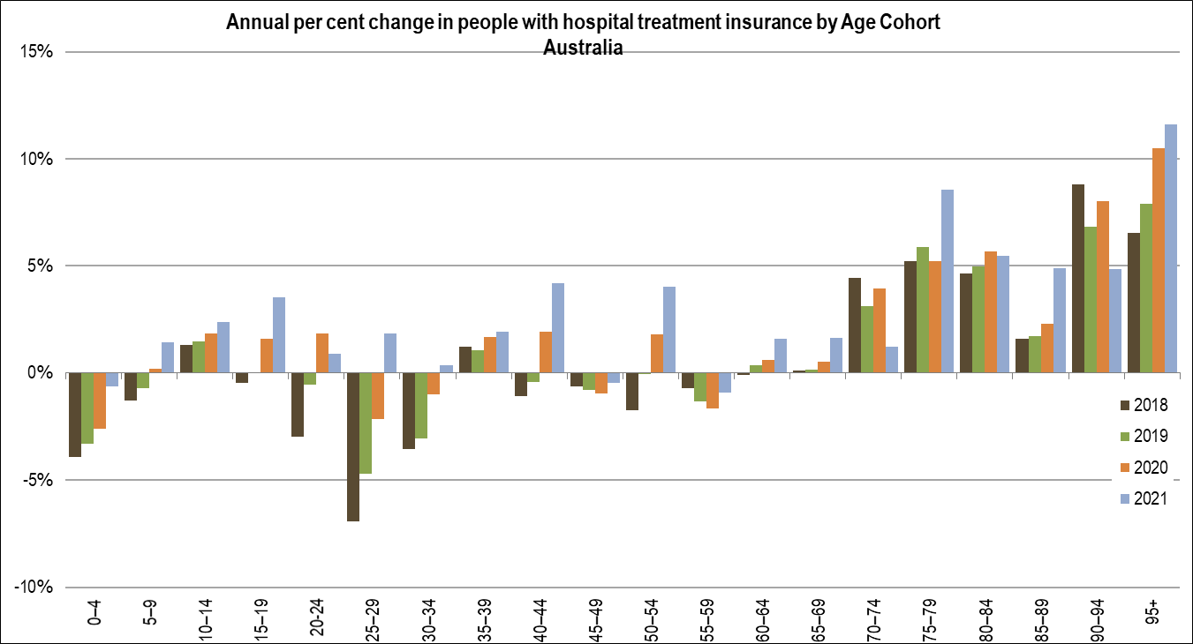

2.3) As we can see the from the data from 2001, the most essential reason families and individuals are not opting for PHIs is the affordability, so to increase take on we need to find ways to decrease the costs surrounding premiums, the gap is especially high for families as they have to cover costs for them and their children programs such as family packages might increase feasibility for purchase for this group.

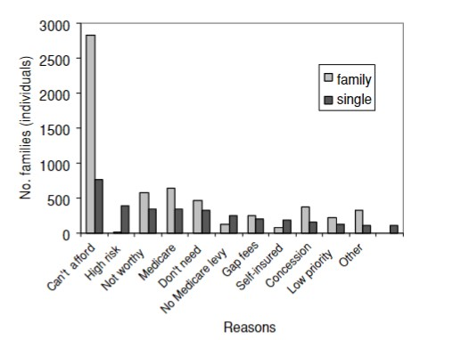

Another Major reasoning the government would want the consumers to choose PHIs is that it can save costs such as patients staying and using hospital facilities, from the data below we can figure out that most patients spend more time in a public hospital than in a private hospital.

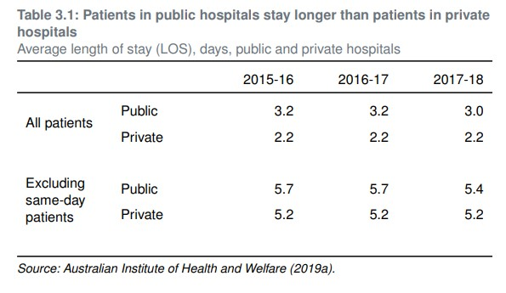

One reason for this could be the affordability for staying in a private hospital is less. We can also see there is a direct correlation with longer stay and the cost incurred on the government.

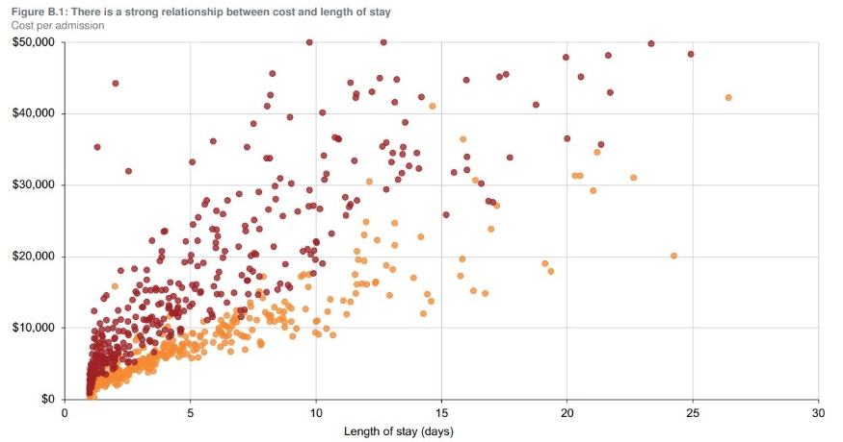

**Critical Analysis of Government Policy Options**

In this section, we do a detailed analysis of all the options provided.

1. **Response 1**

The first policy dictates, every citizen should get a levy and the levy should decrease with age, this entails that the younger or people at less risk for the use of private health care should get more a levy, so it is a better deal for them, and they are more likely to invest in PHIs. The implications of this response would be the growth in the rate of PHIs through younger people or less risky people in the fray which can support the riskier patients in the PHI such as old people. However, financially this can be a huge Burdon on the government as the levy on younger people would spur up a great deal of capital to support this response. This solution could work for a small term plan but could get very heavy on the long term.

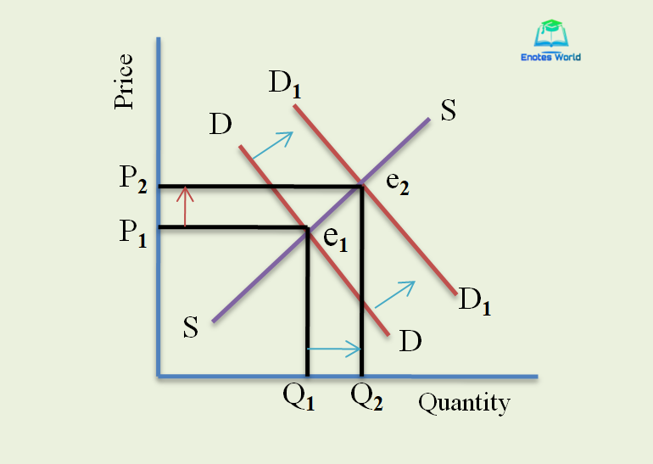

**3.2) Market Equilibrium Analysis**

1. With the introduction of the subsidy, younger individuals, who receive higher subsidies, will experience a decrease in the effective price of PHI. This will lead to an increase in the quantity demanded by younger individuals, shifting the demand curve to the right.
2. The shift in the demand curve will result in a new equilibrium point with a higher quantity demanded (Q2) and potentially a higher price (P2) compared to the initial equilibrium (E1).
3. Simultaneously, older individuals, who receive lower subsidies, may face a higher effective price of PHI. This could result in a decrease in the quantity demanded by older individuals, causing a leftward shift in the demand curve, however the need for the older people for PHIs is more necessary so it will not be able to counteract the younger peoples increase in demand.

The exact magnitude of the shifts in the demand curve and the resulting changes in market equilibrium will depend on the specific subsidy amounts and the price elasticity of demand for PHI across different age groups.

**3.3) Other Market Incentives**

* The market premiums will get cheaper for younger people as insurance companies would be incentivized to take on more young customers and the best way to do that would be to decrease their premium prices. Furthermore, the equilibrium price for the young customers would also change as the profit earned by the companies will not just include the premium prices, but also the subsidy they will be receiving from the government.

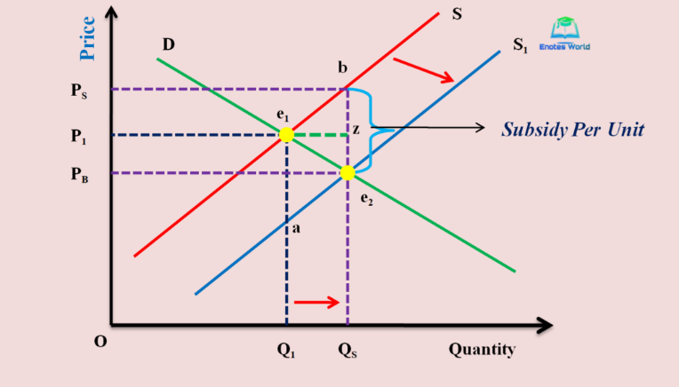

* Incentives for Insurance Brokers and Agents: Insurers may offer additional incentives, such as higher commissions or bonuses, to insurance brokers and agents who successfully sell policies to younger individuals. By aligning the monetary interests of brokers with the age-dependent subsidy structure, insurers can motivate brokers to actively promote private health insurance among the younger demographic.
* Customized Insurance Packages: Insurers may design insurance packages that cater to younger individuals. These packages could include benefits and coverage options that align with the healthcare needs and priorities of this age group. By offering customized packages, insurers can enhance the perceived value of private health insurance for younger individuals, making it more appealing and encouraging them to purchase coverage.

**3.4) Winners**

* Young people – as the subsidy directly targets the younger population, they will be incentivized to use the benefits of PHIs on a lower cost basis.
* Insurers: Insurers may experience increased demand for policies from younger individuals, leading to higher sales and potentially improved profitability.

**Losers**

* Older individuals: older individuals, who receive lower subsidies, may face higher effective prices for private health insurance. This can make it less affordable for them, potentially leading to a decrease in their insurance coverage.
* Government: The government may face increased budgetary pressure due to the subsidy costs associated with encouraging younger individuals to purchase private health insurance.

**3.5) Limitations of the age-based subsidy**

* Risk of Market Distortion: The subsidy may potentially distort the market dynamics by creating an artificial incentive for insurers to primarily target younger individuals who are eligible for higher subsidies.
* Limited Impact on Affordability: While the subsidy lowers the effective price of private health insurance for younger individuals, it may address the underlying affordability concerns that discourage individuals from purchasing coverage.
* Budgetary Considerations: Introducing subsidies can have significant budgetary implications for the government.

1. **Response 2**

4.1) the second policy response involves lowering the income threshold for the Medicare levy surcharge, a tax penalty for individuals without private health cover. By reducing the threshold, the government aims to encourage more individuals to purchase PHI. This policy targets individuals with higher incomes and provides a different approach to incentivizing PHI enrollment. A tax penalty is issued for people without private cover – from $90,000 to $50,000 for singles and from $180,000 to $100,000 for couples/families.

Now we take a deeper look at the level of impact such a policy can have on the market.

Going through the data, if we try to see the population affected by this levy, I.e., people with the income range of 50-90 thousand as an individual which would encompass around 15-20 percent of the population.

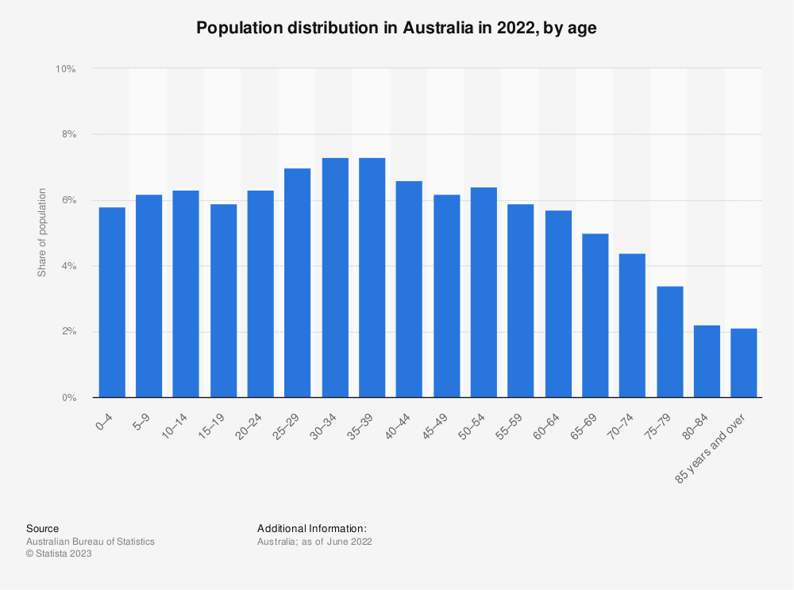

Seeing that a large population would be almost forced to take on the PHIs, this would lead to a huge increase in the amount of costs saved by the government. Furthermore, the government would be in a position where they could spend the newly gained income towards optimization of the healthcare system and improving the industry.

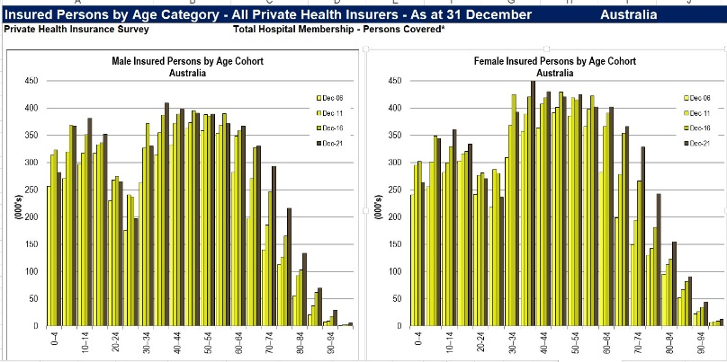

Going through the graphs we can concur that the young population is most likely to be affected by the newly added levy and the overall market would be equalized.

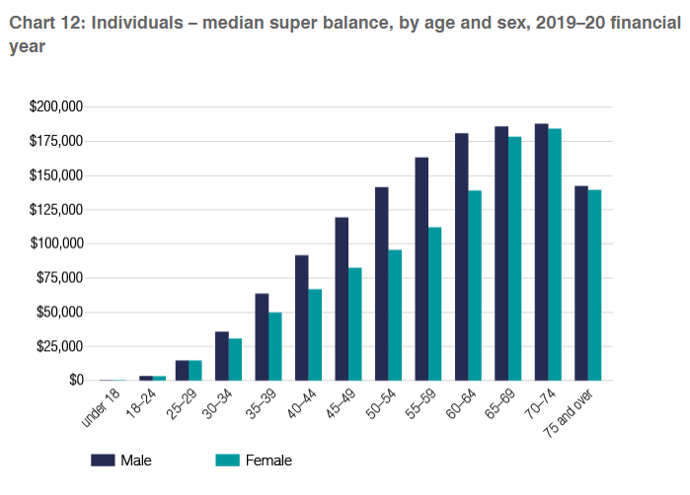

**4.2) Market Analysis**

Shift in equilibrium: The increase in demand for private health insurance policies and potential increase in supply capacity can lead to a new market equilibrium with a higher quantity of policies sold (Q1) and potentially a higher price for policies (P1).

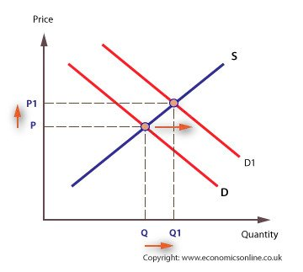

**4.3) Effects on demand and supply for other factors**

* Decreasing the threshold would lead to an increase in quantity demanded for the PHIs as people would be more willing to pay for the PHIs to avoid the tax if they fell in that threshold which would lead to an increase in the equilibrium of demand and supply and have positive shift in the market equilibrium.
* Increased supply capacity: The increase in demand for private health insurance policies may incentivize insurance companies to expand their supply capacity. They may introduce new insurance plans, negotiate with healthcare providers for wider networks, and increase their marketing efforts to capture the growing market. This scenario might increase supply as well.

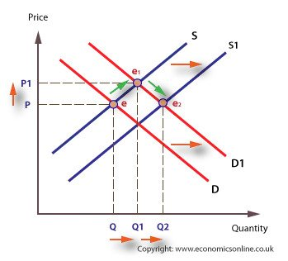

**4.4) Winners**

* Private insurers: Lowering the threshold for the Medicare levy surcharge can incentivize more individuals to purchase private health insurance to avoid the tax penalty. This can lead to increased demand for PHIs.
* Individuals with higher incomes: Individuals with higher incomes who were previously not incentivized to purchase private health insurance may now find it more financially advantageous to obtain coverage to avoid the higher tax penalty.

**Losers:**

* Individuals with lower incomes: Lowering the threshold for the Medicare levy surcharge may not significantly benefit individuals with lower incomes who may already find it difficult to afford private health insurance. They may continue to face challenges in accessing private healthcare services.
* Government (to some extent): The government may experience a decrease in tax revenue from the Medicare levy surcharge due to more individuals opting for private health insurance to avoid the penalty.

**4.5) Limitations**

* Unequal Distribution of Benefits: Lowering the threshold may primarily benefit individuals with higher incomes who were previously not incentivized to purchase private health insurance. Lower-income individuals, who may have more limited financial resources, may still face difficulties in affording coverage.
* Unequal Distribution of Benefits: Lowering the threshold may primarily benefit individuals with higher incomes who were previously not incentivized to purchase private health insurance. Lower-income individuals, who may have more limited financial resources, may still face difficulties in affording coverage.
* Increasing the supply capacity may pose challenges for insurance companies if they need to balance the affordability of policies with maintaining adequate coverage and managing costs.

1. **Response 3**

5.1) the third policy response focuses on implementing regulatory reforms to the production and supply of medical equipment, with the expectation of lowering the price of surgeries and hospital care. This approach aims to make PHI more affordable and attractive to potential customers.

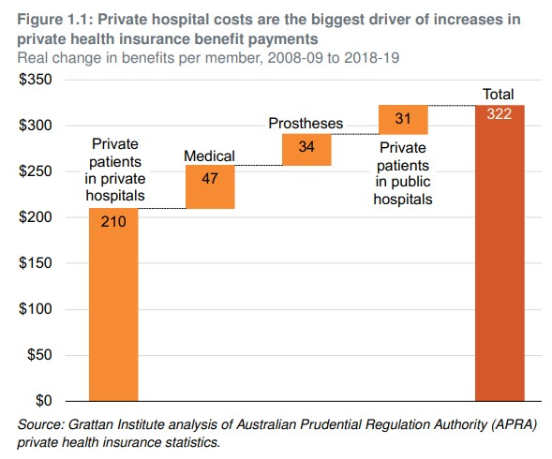

When we take a focused look at the implications of this response, the direct effect on the market is the increase in affordability for the PHIs through the decreased costs and increase in the level of healthcare provided by the Australian healthcare sector, this in turn would cause a chain of effects which would convince a higher amount of population into procuring more PHIs as they would be cheaper and the perceptive values of them would in turn become higher, I.e. More people would believe they are worth investing in over Medicare.

**5.2) Market Analysis**

* Increase in demand: Lowering the price of surgeries increases the demand for private health insurance policies. The reduced costs make private health insurance more attractive to individuals who were previously deterred by high healthcare expenses.
* Improved perception: Lower prices may positively influence the perception of private health insurance, making it a more appealing option for individuals who were skeptical about its value proposition.
* Adjusted pricing strategies: Lowering the price of surgeries and hospital care may require private healthcare providers to adjust their pricing strategies.
* Shift in equilibrium: The decrease in the price of surgeries and hospital care, coupled with the potential increase in demand for private health insurance policies, may lead to a new market equilibrium. This new equilibrium could result in a higher quantity of policies sold (Q1) and potentially a lower price for policies (P1).



**5.3) Focusing On other Markets affected by the Response:**

1. Medical Equipment and Supplies Market: Lowering the price of surgeries and hospital care puts pressure on the pricing of medical equipment and supplies. This could impact manufacturers, distributors, and suppliers in the medical equipment market, potentially leading to lower revenues and reduced profit margins.
2. Public Healthcare System: Lower prices for surgeries and hospital care in the private sector may impact the public healthcare system. As individuals opt for private providers due to affordability, it reduces the demand for public healthcare services, leading to potential resource reallocation within the public sector. The public healthcare system may experience reduced patient volumes for specific procedures, potentially resulting in cost savings.

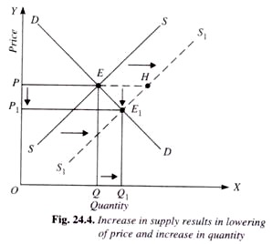

**5.4) Winners:**

* Consumers: Lowering the price of surgeries and hospital care can benefit consumers, it can lead to reduced out-of-pocket expenses and increased affordability of healthcare services.
* Public healthcare system: Lower prices for surgeries and hospital care can alleviate some of the strain on the public healthcare system by reducing the demand for private health insurance and potentially attracting individuals back to public hospitals.

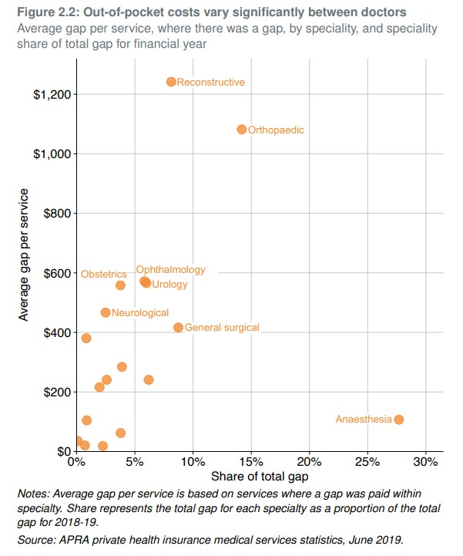

**Losers:**

* Private healthcare providers: Lower prices may impact the profitability of private healthcare providers, especially those that heavily rely on revenue from private health insurance policies. They may face reduced financial incentives and potential challenges in maintaining the quality of services.
* Private health insurance companies: If lower prices for surgeries and hospital care reduce the perceived value of private health insurance, insurance companies may face challenges in retaining policyholders and attracting new customers.

**5.5) Limitations**

* Incentives for Innovation: Lower prices might disincentivize healthcare providers from investing in modern technologies, research, and innovation. The financial strain resulting from reduced revenues could hinder their ability to adopt advanced treatments
* Potential Shifts in Utilization: Lower prices may lead to increased utilization of healthcare services, as individuals find private health insurance more affordable. This could result in higher demand for surgeries and hospital care, potentially straining the capacity of healthcare providers.
* Long-term Viability: Lowering prices may provide short-term benefits but could raise concerns about the long-term sustainability of the private health insurance market.

1. **Recommendation**

6.1) After going through all the responses given, I would suggest the response to lower the threshold for Medicare levy surcharge, although there is one addition that I would like to make, we need to add a 30% tax rebate on people with the income less than $90,000, as the financial pressure on the lower class income category would get too high which could lead to a worse situation for the individuals involved. This additional response would also add to the number of people taking up the rate of PHIs.

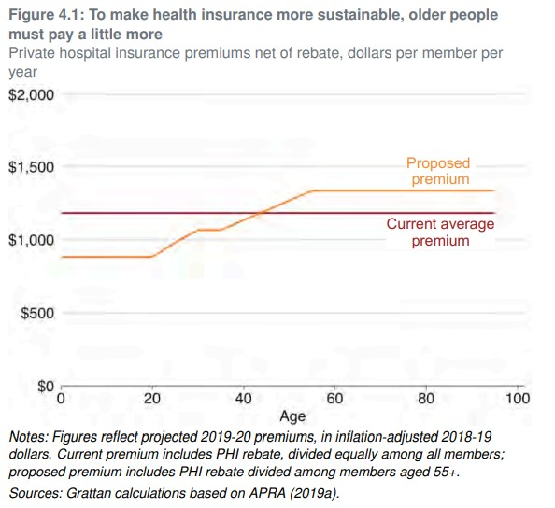

We can see from the scenario from 2001, where the government added a 30% rebate to all PHI policies which along with LHC were considered the most effective factors for the increase in the take on rate by the people. The idea behind this was to increase affordability of PHI.

6.2) My recommendation is response 2 because the lowering of threshold would lead to more revenue for the government and additionally get more younger and newer applicants to sign up for PHIs, this would lead the government to have the capability of improving the quality of healthcare in Australia, the response also leads to reduced pressure on the public healthcare system, reduction on the strain of the public healthcare system would lead to shorter queue times and improved access to the public system. This system supports the dual healthcare system by incentivizing PHIs and improving public healthcare as well, Minimizes Disruption and Regulatory Burden: Compared to other policy options, Response 2 involves a straightforward regulatory change to the Medicare levy surcharge threshold. This minimizes disruption to the existing private health insurance market and reduces the administrative burden on both insurers and individuals. It offers a pragmatic solution that can be implemented more efficiently compared to more complex interventions.

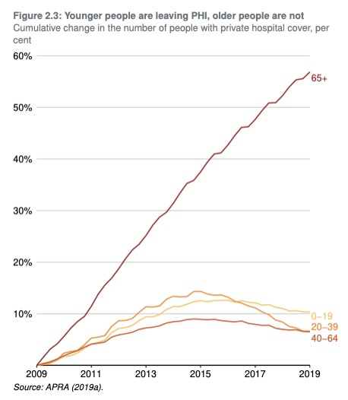

6.3) Reasons for choosing response 2 over others

* Response 2 directly targets the issue of declining private health insurance enrollment by providing a financial incentive for individuals to obtain coverage. By lowering the threshold for the Medicare levy surcharge, younger and healthier individuals, who are more likely to opt out of private insurance, are motivated to purchase coverage to avoid the surcharge.
* Response 2 will cause the least complexities and administrative burdens
* Response 2 leads to a more balanced risk pool. Younger and healthier individuals joining the pool reduce the concentration of higher-risk individuals, contributing to the long-term sustainability of private insurers. This helps stabilize premiums and ensures access to affordable private health insurance options for a broader range of individuals.

Now looking at the shortcoming of response 2, which is the increased taxation put on the people and especially people making lower wages, to counter act and increase the feasibility of the response the government should consider adding a 30% tax rebate, adding the rebate will increase affordability and help poorer people afford PHIs. This will not only increase the number of people using PHIs but also make it a fair deal for the poorer consumers.

**Conclusion**

Based on a thorough evaluation of the policy options, Response 2, which involves lowering the threshold for the Medicare levy surcharge, is recommended. This policy has the potential to incentivize individuals to purchase private health insurance, addressing the decline in membership and mitigating the risk of adverse selection. By reducing the burden on the public healthcare system, it promotes a more balanced risk pool and enhances the long-term sustainability of the private health insurance market. Monitoring and evaluation will be crucial to assess the effectiveness of this policy in achieving its objectives and ensuring affordable and accessible healthcare for all Australians.

**References**

* **Manager, External Data Reporting. "Private Health Insurance Annual Coverage Survey." APRA - Australian Prudential Regulation Authority, 21 July 2022,** [**https://www.apra.gov.au/operations-of-private-health-insurers-annual-report**](https://www.apra.gov.au/operations-of-private-health-insurers-annual-report)**.**
* **Duckett, Stephen, and Kristina Nemet. Saving Private Health 1: Reining in Hospital Costs and Specialist Bills. Grattan Institute, 2019.**
* **Cheng, Terence. "Private health insurance rebates don’t serve their purpose. Let’s talk about scrapping them." The Conversation, 7 February 2018**
* **Rana, R.H., Alam, K. & Gow, J. Selection of private or public hospital care: examining the care-seeking behaviour of patients with private health insurance. BMC Health Serv Res 20, 380 (2020).** [**https://doi.org/10.1186/s12913-020-05253-y**](https://doi.org/10.1186/s12913-020-05253-y)
* **Doiron, Denise, and Nathan Kettlewell. "The Effect of Health Insurance on the Substitution between Public and Private Hospital Care." Economic Record, vol. 94, no. 305, June 2018.**
* **Buchmueller, Thomas C., Terence C. Cheng, Ngoc T.A. Pham, and Kevin E. Staub. "The effect of income-based mandates on the demand for private hospital insurance and its dynamics." Journal of Health Economics, November 2020.**
* **Cheng, T. (2014). Measuring the effects of reducing subsidies for private insurance on public expenditure for health care. Journal of Health Economics, 33(1), 159-179.**
* **Gans, J. (2005). Does Australia’s Health Insurance System Really Provide Insurance? Policy, 20(3), 10-14.**
* **Cheng, T. (2018). Private health insurance rebates do not serve their purpose. Let us talk about scrapping them. The Conversation. Retrieved from [**[**https://theconversation.com/private-health-insurance-rebates-dont-serve-their-purpose-lets-talk-about-scrapping-them-91061**](https://theconversation.com/private-health-insurance-rebates-dont-serve-their-purpose-lets-talk-about-scrapping-them-91061)**]**
* **Palangkaraya, A., & Yong, J. (2005). Effects of Recent Carrot-and-Stick Policy Initiatives on Private Health Insurance Coverage in Australia. Economic Record, 81(254), 262-272.**
* **Vaithianathan, R. (2005). A Critique of the Private Health Insurance Regulations. Australian Economic Review, 37(3), 257–270.**